Operating System Lab Observation

1a
Program:
#include <stdio.h>
#include <unistd.h>
#include <fcntl.h>

int main()
{
int fd;
char buffer[50];

/* open() – create and open a file */
fd = open("sample.txt", O_CREAT | O_RDWR, 0644);

if (fd < 0)
{
printf("File opening failed\n");
return 1;
}

/* write() – write data into file */
write(fd, "Hello OS Lab", 12);

/* move file pointer to beginning */
lseek(fd, 0, SEEK_SET);

/* read() – read data from file */
read(fd, buffer, 12);

/* display data */
printf("Data read from file: %s\n", buffer);

/* close() – close the file */
close(fd);

return 0;
}
Output:
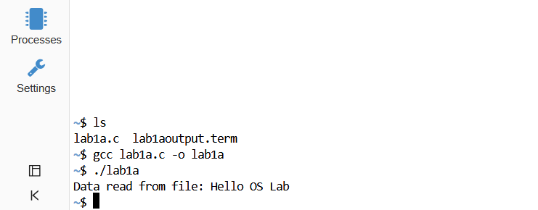

1b:
Program:
#include <stdio.h>
#include <dirent.h>

int main()
{
DIR *d;
struct dirent *entry;

/* open current directory */
d = opendir(".");

if (d == NULL)
{
printf("Directory cannot be opened\n");
return 1;
}
/* read directory entries */
printf("Directory contents:\n");
while ((entry = readdir(d)) != NULL)
{
printf("%s\n", entry->d_name);
}
/* close directory */
closedir(d);
return 0;
}
Output:
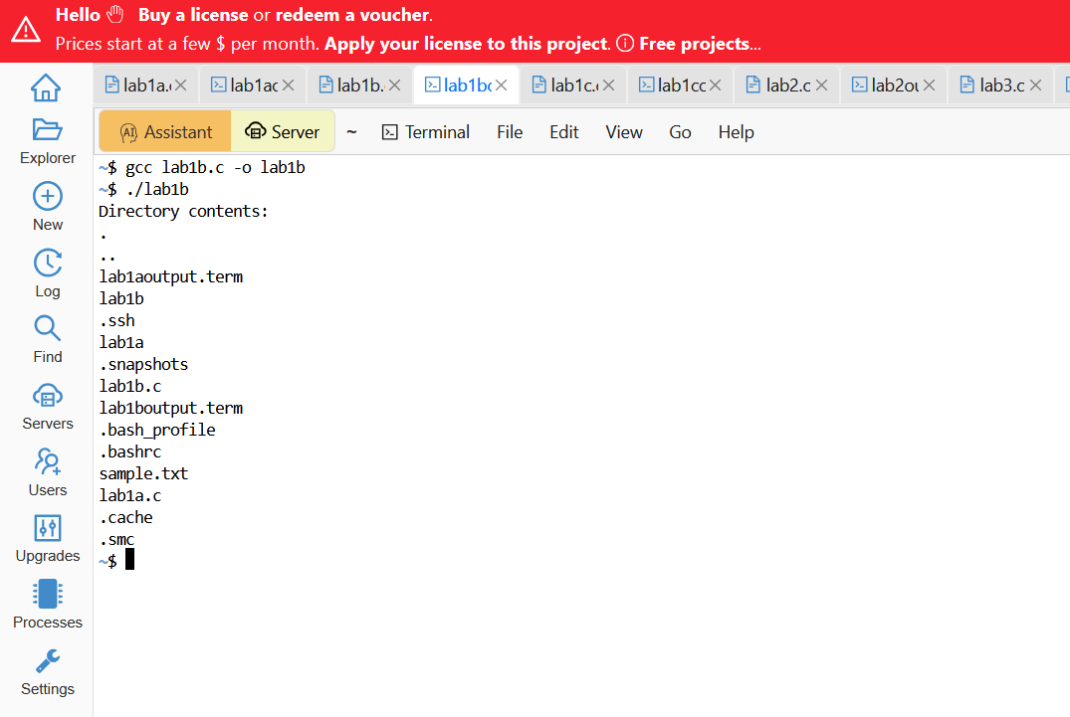

1c:
Program:
#include<stdio.h>
#include<unistd.h>
#include<sys/types.h>
void main()
{
printf("\nBefore declaring FORK.");
printf("\nThe value of PID is : ");
printf("\n%d",getpid());
printf("\nThe value of PPID is : ");
printf("\n%d",getppid());

pid_t pid=fork();//Used to create child process
if(pid==0)//Child Process
{
printf("\nAfter declaring FORK.");
printf("\nThe value of PID is zero.");
printf("\nThe value of PID is : ");
printf("\n%d",getpid());
printf("\nThe value of PPID is : ");
printf("\n%d",getppid());
}
else if(pid>0)//Parent Process
{
printf("\nAfter declaring FORK.");
printf("\nThe value of PID is greater than zero.");
printf("\nThe value of PID is : ");
printf("\n%d",getpid());
printf("\nThe value of PPID is : ");
printf("\n%d",getppid());
}
else//Error
{
printf("\nAfter declaring FORK.");
printf("\nThe value of PID is less than zero.");
printf("\nThe value of PID is : ");
printf("\n%d",getpid());
printf("\nThe value of PPID is : ");
printf("%d",getppid());
}

}

Output:
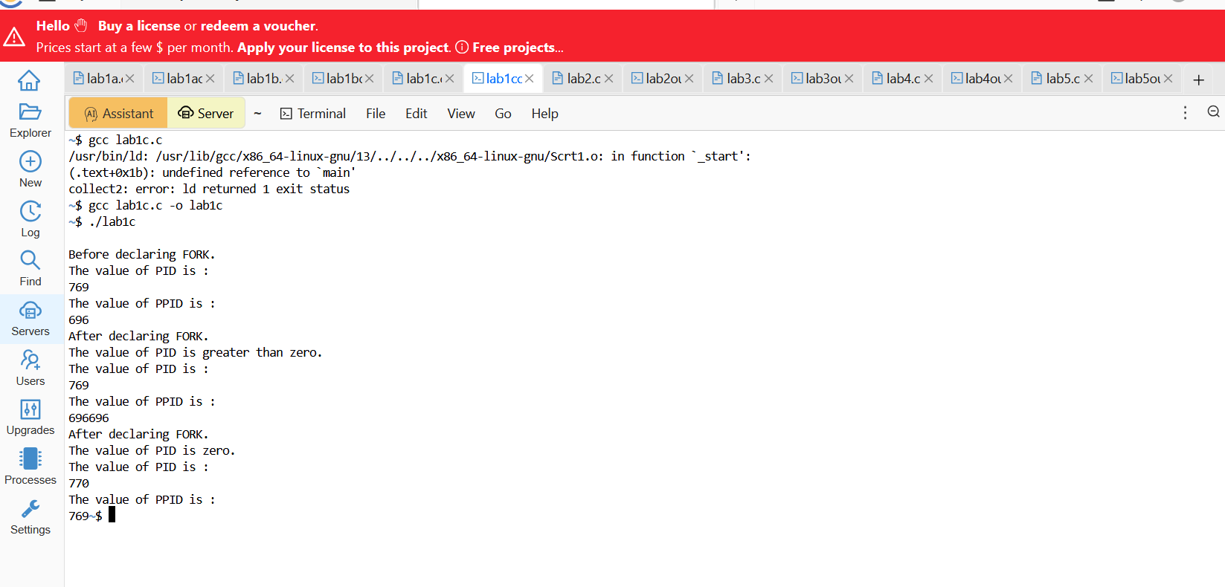

Lab2:
Program:
#include <stdio.h>
// FCFS Scheduling
void fcfs(int n, int bt[]) {
int wt[10], tat[10];
wt[0] = 0;
for(int i = 1; i < n; i++)
wt[i] = wt[i-1] + bt[i-1];
printf("\nFCFS Scheduling:\n");
printf("Process\tBurst Time\tWaiting Time\tTurnaround Time\n");
for(int i = 0; i < n; i++) {
tat[i] = wt[i] + bt[i];
printf("P%d\t\t%d\t\t%d\t\t%d\n", i+1, bt[i], wt[i], tat[i]);
}
}
// Round Robin Scheduling
void roundRobin(int n, int bt[], int tq) {
int rem_bt[10], wt[10], tat[10];
int t = 0;
for(int i = 0; i < n; i++) {
rem_bt[i] = bt[i];
wt[i] = 0;
}
while(1) {
int done = 1;
for(int i = 0; i < n; i++) {
if(rem_bt[i] > 0) {
done = 0;
if(rem_bt[i] > tq) {
t += tq;
rem_bt[i] -= tq;
} else {
t += rem_bt[i];
wt[i] = t - bt[i];
rem_bt[i] = 0;
}
}
}
if(done == 1)
break;
}

printf("\nRound Robin Scheduling (Time Quantum = %d):\n", tq);
printf("Process\tBurst Time\tWaiting Time\tTurnaround Time\n");

for(int i = 0; i < n; i++) {
tat[i] = bt[i] + wt[i];
printf("P%d\t\t%d\t\t%d\t\t%d\n", i+1, bt[i], wt[i], tat[i]);
}
}

int main() {
int n, tq;
int bt[10];

printf("Enter number of processes: ");
scanf("%d", &n);
printf("Enter burst times:\n");
for(int i = 0; i < n; i++) {
printf("P%d: ", i+1);
scanf("%d", &bt[i]);
}
fcfs(n, bt);
printf("\nEnter Time Quantum for Round Robin: ");
scanf("%d", &tq);
roundRobin(n, bt, tq);
return 0;
}

Output:
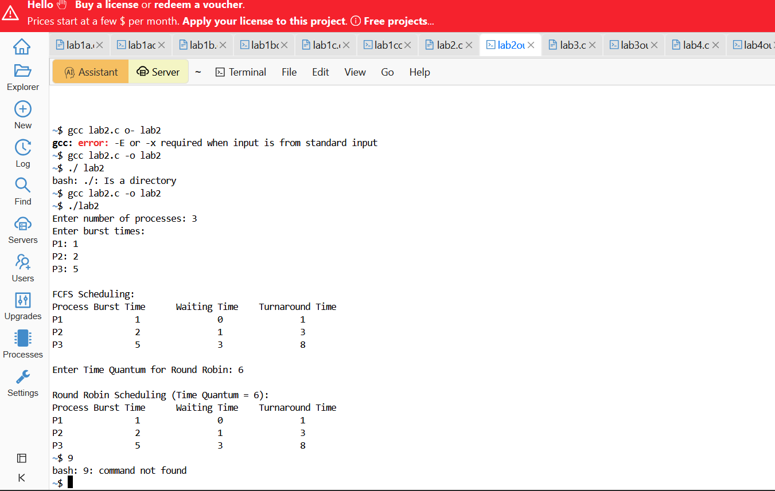

Lab3:
Program:
#include <stdio.h>

int main() {
int n, i, j;
int bt[10], pr[10], p[10];
int wt[10], tat[10], temp;

printf("Enter number of processes: ");
scanf("%d", &n);

for(i = 0; i < n; i++) {
p[i] = i + 1;
printf\

Enter Burst Time and Priority for P%d: ", p[i]);
scanf("%d %d", &bt[i], &pr[i]);
}
// Sort by Priority
for(i = 0; i < n; i++) {
for(j = i + 1; j < n; j++) {
if(pr[i] > pr[j]) {
temp = pr[i]; pr[i] = pr[j]; pr[j] = temp;
temp = bt[i]; bt[i] = bt[j]; bt[j] = temp;
temp = p[i]; p[i] = p[j]; p[j] = temp;
}
}
}
wt[0] = 0;
for(i = 1; i < n; i++)
wt[i] = wt[i - 1] + bt[i - 1];
for(i = 0; i < n; i++)
tat[i] = wt[i] + bt[i];
printf("\nProcess\tBT\tPriority\tWT\tTAT\n");
for(i = 0; i < n; i++)
printf("P%d\t%d\t%d\t\t%d\t%d\n", p[i], bt[i], pr[i], wt[i], tat[i]);
return 0;
}
Output:
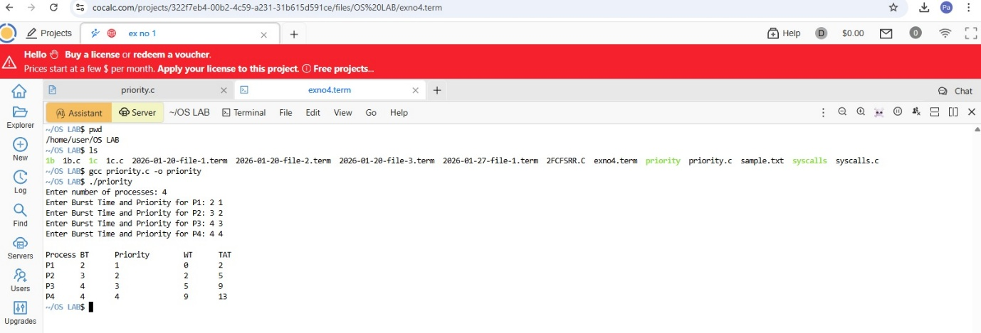

Lab4:
Program:
#include <stdio.h>
#include <pthread.h>
#include <semaphore.h>
#include <unistd.h>
#define N 5
sem_t forks[N];
pthread_t philosophers[N];
void* philosopher(void* num) {
int id = *(int*)num;
printf("Philosopher %d is thinking\n", id);
sleep(1);
sem_wait(&forks[id]);
sem_wait(&forks[(id + 1) % N]);
printf("Philosopher %d is eating\n", id);
sleep(1);
sem_post(&forks[id]);
sem_post(&forks[(id + 1) % N]);
printf("Philosopher %d finished eating\n", id);
return NULL;
}
int main() {
int i, id[N];

for (i = 0; i < N; i++)
sem_init(&forks[i], 0, 1);
for (i = 0; i < N; i++) {
id[i] = i;
pthread_create(&philosophers[i], NULL, philosopher, &id[i]);
}
for (i = 0; i < N; i++)
pthread_join(philosophers[i], NULL);
return 0;
}
Output:
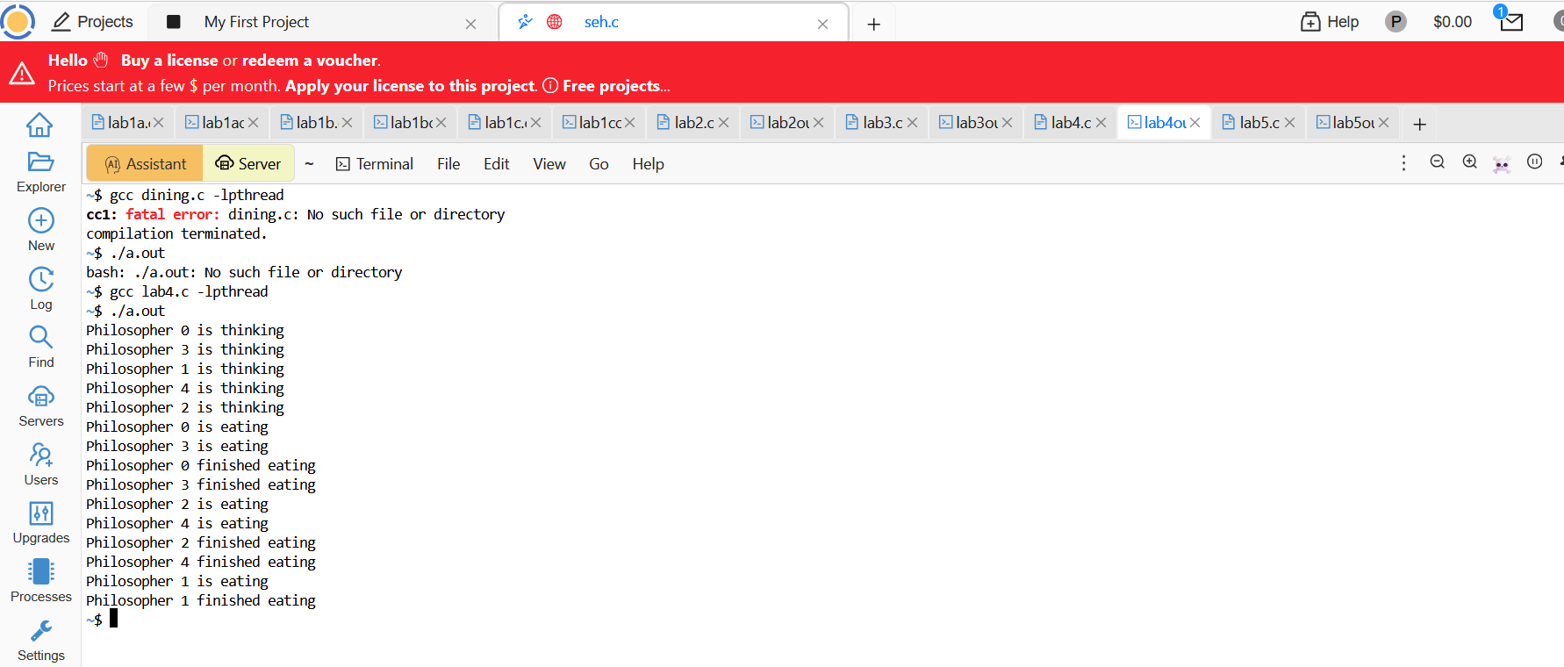

Lab5:
Program:
#include<stdio.h>
void firstFit(int blockSize[], int m, int processSize[], int n)
{
int alloca on[n];
for(int i=0;i<n;i++)
alloca on[i]=-1;

for(int i=0;i<n;i++)
{
for(int j=0;j<m;j++)
{
if(blockSize[j] >= processSize[i])
{
alloca on[i] = j;
blockSize[j] -= processSize[i];
break;
}
}
}

prin ("\nFIRST FIT\nProcess No.\tProcess Size\tBlock No.\n");
for(int i=0;i<n;i++)
{
if(alloca on[i]!=-1)
prin ("%d\t\t%d\t\t%d\n",i+1,processSize[i],alloca on[i]+1);
else
prin ("%d\t\t%d\t\tNot Allocated\n",i+1,processSize[i]);
}
}

void bestFit(int blockSize[], int m, int processSize[], int n)
{
int alloca on[n];
for(int i=0;i<n;i++)
alloca on[i]=-1;

for(int i=0;i<n;i++)
{
int bestIdx=-1;
for(int j=0;j<m;j++)
{
if(blockSize[j]>=processSize[i])
{
if(bestIdx==-1 || blockSize[j]<blockSize[bestIdx])
bestIdx=j;
}
}

if(bestIdx!=-1)
{
alloca on[i]=bestIdx;
blockSize[bestIdx]-=processSize[i];
}
}

prin ("\nBEST FIT\nProcess No.\tProcess Size\tBlock No.\n");
for(int i=0;i<n;i++)
{
if(alloca on[i]!=-1)
prin ("%d\t\t%d\t\t%d\n",i+1,processSize[i],alloca on[i]+1);
else
prin ("%d\t\t%d\t\tNot Allocated\n",i+1,processSize[i]);
}
}

int main()
{
int blockSize[] = {100, 500, 200, 300, 600};
int processSize[] = {212, 417, 112, 426};

int m = 5;
int n = 4;

int block1[5], block2[5];
for(int i=0;i<m;i++)
{
block1[i]=blockSize[i];
block2[i]=blockSize[i];
}

firstFit(block1,m,processSize,n);
bestFit(block2,m,processSize,n);

return 0;
}
Output:

